

Equality and diversity in the Oxford City Council workforce

Report of the Equality and Diversity Review Group

Commissioned by Oxford City Council’s Scrutiny Committee

May 2016
Contents

Foreword 2
Summary of recommendations 4
Appendices 6
Introduction 6
Background 6
Terms of reference 7
Methods of investigation 7
Profile of the Council workforce 7
Ethnicity 7
Gender 12
Sexual orientation 16
Disability 17
Age 18
Barriers to recruitment and career progression 19
Reducing barriers 20
Preventing and addressing discrimination 23
Being inclusive of LGBT employees 25
Conclusion 27

Foreword

Equality and diversity aren’t just nice things to have in a workplace. They matter because a person’s sexuality, gender, ethnicity, and disability matter to them. When our Council gets diversity right and looks more like the communities we serve, our Council gets more things right and delivers the best possible value for money for local taxpayers.

Britain is a more equal society, if we look at the strides forward our historically most discriminated against communities have taken in the last twenty years. For some communities, here and around the country, the speed and scale of social change has felt like a sharp break with the intolerance of the past. For others, the wins they’ve racked up can feel smaller.

This review delves deep into the latest data to find out how our Council is reflecting these changes across all Oxford’s communities. As importantly, this review looks at whether more could be done to make our Council more inclusive and diverse.
Like the social progress we’ve seen here in Oxford and across the country, the situation is the same: A lot has changed, but there’s more to do to complete the longer march to equality.

The data shows that the LGBT workforce is very small and unwilling to disclose their sexuality. The Council has the largest ever BME workforce, but the workforce is clustered in the lower wage jobs and almost non-existent in senior roles. Women are under-represented in senior leadership roles.
The Council’s workforce has been changing to look more like the diverse communities that it serves. Good policies currently in place have helped to bring this about and tackle discrimination. However, further improvements are possible, and we offer concrete accounts of the gaps that need filling and our thinking on the measures that can best fill them.

Reaching potential employees from diverse backgrounds involves a gear-shift. The Council shouldn’t be putting out job adverts on the channels we prefer; we should be putting out job adverts on all the channels and in all the forms most easily accessed by the communities we want to work for the city.

Monitoring matters. In the case of the issues discussed here, monitoring matters even more than an employee’s natural desire to feel protective about personal information. The Council doesn’t ask for such personal information because it’s nosey or box-ticking to comply with regulations. Information matters because it helps to make things better, and the Council could make that plainer to staff.

Clearly the Council needs to build confidence in the monitoring that it does. Otherwise employees will go on declining to disclose and the Council will keep on facing under-reporting.

In particular, the Council can take practical steps to build a workplace that’s friendlier to transgender employees, and how we gather together personal information on employees is central to that.

I want to thank the councillors on this review panel and the council officers – in particular Scrutiny Officer Andrew Brown – for their time, commitment, and energy in developing this review.

Special thanks go to the Trade Unions who campaign for dignity and respect in Oxford City Council’s workplace, and whose contributions on behalf of LGBT, black, women, and disabled members were fundamental to the scoping, investigating, and writing of this review.

I trust the review will meet with the backing of the Scrutiny Committee and the City Executive Board, and hope that it forms the basis for promoting equality and diversity within the Council workforce.

Councillor Tom Hayes
Chair of the Equality and Diversity Review Group

Summary of recommendations

Recommendation 1 – That the Council undertakes accessibility audits of its employment premises at appropriate intervals. Consideration should be given to how frequently these audits should take place at each workplace premises and to the setting of maximum intervals between audits.

Recommendation 2 – That the Council reviews recruitment branding to better target any vacancies at under-represented groups and young people, including utilising settings or channels that are less traditional to local government but more inclusive.

Recommendation 3 – That the Council continues to promote itself as an inclusive employer through outreach activities including continuing to hold open recruitment sessions in community settings, reaching out in schools through the Business in the Community partnership, and attending job fairs and community meetings.

Recommendation 4 – That the Council investigates opportunities to advertise multiple vacancies in community settings at low cost, which could include making use of community newspaper social media platforms, as well as community newspapers and, as long as those running them are willing, community centres.

Recommendation 5 – That the Council makes use of its assets to promote itself as an inclusive employer, including Streetscene vehicles.

Recommendation 6 – That the Council reviews its Talent Management Framework and researches whether the inclusion of a more targeted talent management programme would appeal to under-represented groups, as well as what such a programme would include.

Recommendation 7 – That the Council emphasises the value it attaches to the ability to speak a second language by including this skill in the desirable criteria for selected customer-facing job vacancies, such as Tenancy Management Officers and Customer Service Officers.

Recommendation 8 – That the Council undertakes a workforce skills audit with the purpose of identifying priority competencies and hidden talents that aren’t currently being utilised but would benefit to the organisation, including the ability to speak a second language.

Recommendation 9 – That the Council considers the feasibility of having staff who are known to speak a second language ‘on call’ to communicate with customers who speak little or no English, and whether these staff could be rewarded with a small pay supplement.

Recommendation 10 – That all Council employees are reminded of the Council’s Fair Employment Statement and employment policies at least annually. These documents should also be prominent and easily accessible on the Council’s Intranet.

Recommendation 11 – That all Council employees are at least annually made aware of their responsibility to challenge discriminatory language and behaviour in the workplace, wherever that may be, as matter of course.

Recommendation 12 – That unconscious bias training is provided to the Council’s most frequent recruiting managers and HR Business Partners. Ideally this would be followed up with annual refresher courses in order to maintain awareness and compliance with good practice.

Recommendation 13 – That the Council seeks to obtain better value from its status as a Stonewall Diversity Champion and, failing that, considers whether the small membership fee would be better invested in other means of tackling discrimination.

Recommendation 14 – That the Council continues to ask employees to review and complete their personal details, including sensitive information such as their sexual orientation, on at least an annual basis, as well as continuing to target identified data gaps. Explanation should be provided as to why sensitive personal information is held by the organisation and the wider benefits of doing so.

Recommendation 15 – That the Council maintains a watching brief on good practice in workforce equalities monitoring and continues to keep its own monitoring arrangements under review, including how questions are asked and the language used as well as the continued inclusion of a ‘prefer not to say’ option.

Recommendation 16 – That consideration is given to whether the sensitive personal data of applicants and employees requested and held by the Council should be more inclusive of transgender people. For example, the Council should consider consulting with appropriate individuals and Trade Unions on adding an appropriately worded gender identity field to its monitoring forms, with the clear purpose of building equality and identifying discrimination.

Recommendation 17 – That the Council adopts gender-neutral terms on forms as part of its ongoing work to be as inclusive as possible, for instance, giving consideration to adding the title Mx in addition to the more established gendered titles such as Mr, Mrs, Miss and Ms.

Recommendation 18 - That consideration is given to whether there is merit in phasing out the use of titles on Council forms and databases over the medium term if this would be supported by the Trade Unions.

Appendices

Appendix 1 – Project scope - Equality and Diversity Review Group
Appendix 2 – Analysis of workforce equalities data

Introduction

- The Equality and Diversity Review Group is a cross-party working group established by Oxford City Council’s Scrutiny Committee during the 2015/16 Council year. The Review Group was asked to look at whether more can reasonably be done to promote equality and diversity within the Council’s workforce. The members of the Review Group are Councillors Hayes (Chair), Altaf-Khan, Taylor and Thomas.

Background

- Oxford is an ethnically and culturally diverse city, with the third highest minority ethnic population in the South East of England. Black and Minority Ethnic (BME) and other European communities across Oxford account for 28% of the population and 36% of residents are of non-white British ethnic origin.

- Oxford City Council is an employer committed to increasing the diversity of its workforce and providing an inclusive work environment with equality of opportunity for all employees.

- Unlike many local authorities, the Council has retained a large manual workforce within its Direct Services operation, which accounts for approximately half of the total Council workforce.

- The Council produces Annual Workplace Equalities Reports which include statistics and commentary on the diversity of the Council workforce as well as recruitment activity, the gender pay gap and disciplinary and grievance cases. These reports show that groups with protected characteristics (under the Equality Act 2010) tend to be under-represented on the Council workforce.

- The Council has targets in place for increasing employment amongst BME groups and disabled people, and regularly monitors the following ‘Corporate Health’ indicators (results as of March 2016):
- The percentage of employees with a disability - 8.2% (target 10%);
- The percentage of black and minority ethnic employees - 7.6% (target 9%).

- The Scrutiny Committee has previously focused on the employment of black and minority ethnic (BME) groups on the Council’s workforce and in 2014 made five recommendations aimed at increasing the number of employees from BME groups. At that time BME employees made up 6.9% of the workforce but following a number of initiatives (including some improvements recommended by the Scrutiny Committee), this figure increased to 7.8% in December 2015. While this figure is the highest ever recorded, the figure remains low compared with the population of the city.

Terms of reference

- The Review Group considered the annual workforce equalities report for 2014/15, and took advice from Council Officers when scoping this review and agreed that it’s key lines of enquiry would be:
- What barriers are faced by under-represented groups in recruitment and career progression at the City Council?
- How does the Council prevent and address discrimination, including specifically discrimination against LGBT employees?

Methods of investigation

- The Equality and Diversity Review Group met four times from October 2015 to April 2016. The Review Group’s findings and recommendations have been informed by evidence provided by Council Officers and Trade Union representatives, as well as workforce equalities data, a literature review and desk research. All meetings were held in private to ensure a full and frank debate.

Profile of the Council workforce

- The Review Group looked in detail at the workforce equalities data held by the Council. This section provides statistics and commentary on the composition and profile of the Council workforce in terms of ethnicity, gender, sexual orientation, disability and age (the Review Group did not look at religion). The equalities data is presented in a series of charts which are included below. Larger versions of figures 1-9 are also included in Appendix 2.

Ethnicity
- The Review Group dug deeper into the data presented in the workforce equality reports by examining gender and ethnicity data at service area level and at each pay grade. The Review Group also compared workforce equalities data from December 2015 with census data from 2011, which is not a perfect comparator but provides a reasonable picture of the population served by the Council. This enabled the Review Group to make a number of observations about the ethnic profile of the Council workforce and identify where under-representations of different groups are most prevalent.

- Figure 1 presents a comparison of workforce ethnicity data with census data for Oxford, excluding some 4,000 short-term international migrants who are not usually resident in the City. The grey bars show the degree of representation that different ethnic groups have on the Council workforce as a proportion of the size of these groups in the local population. These grey bars would all be at 100% if the ethnic composition of the Council workforce exactly mirrored the profile of Oxford. However, the Review Group identified a number of reasons why this would not be expected to be the case, as explained in paragraphs 15-18.

- The Review Group found that all groups with significant local populations are under-represented on the Council workforce with the exception of the White British group, which is particularly over-represented, and the Black Caribbean Group, which is slightly over-represented. The Other Mixed group is the only other ethnic group that has something approaching the level of representation that could be expected based on the profile of the local population.

- Of the remaining ethnic groups, the Asian / Asian British groups appear to be particularly under-represented on the Council workforce. For example the number of Pakistani employees is about one quarter what could be expected based on the number Oxford residents who identify as being of Pakistani origin. The proportion of Bangladeshi employees is lower still. No employees describe their ethnic origin as Arab but this is one of the smallest ethnic groups in the local population, with fewer than 1000 Arabs resident in Oxford. There is also a small but not insignificant number of staff (5.6%) who have declined to provide their ethnic origin. It is therefore likely that the figures for at least some of the BME groups are slightly understated.

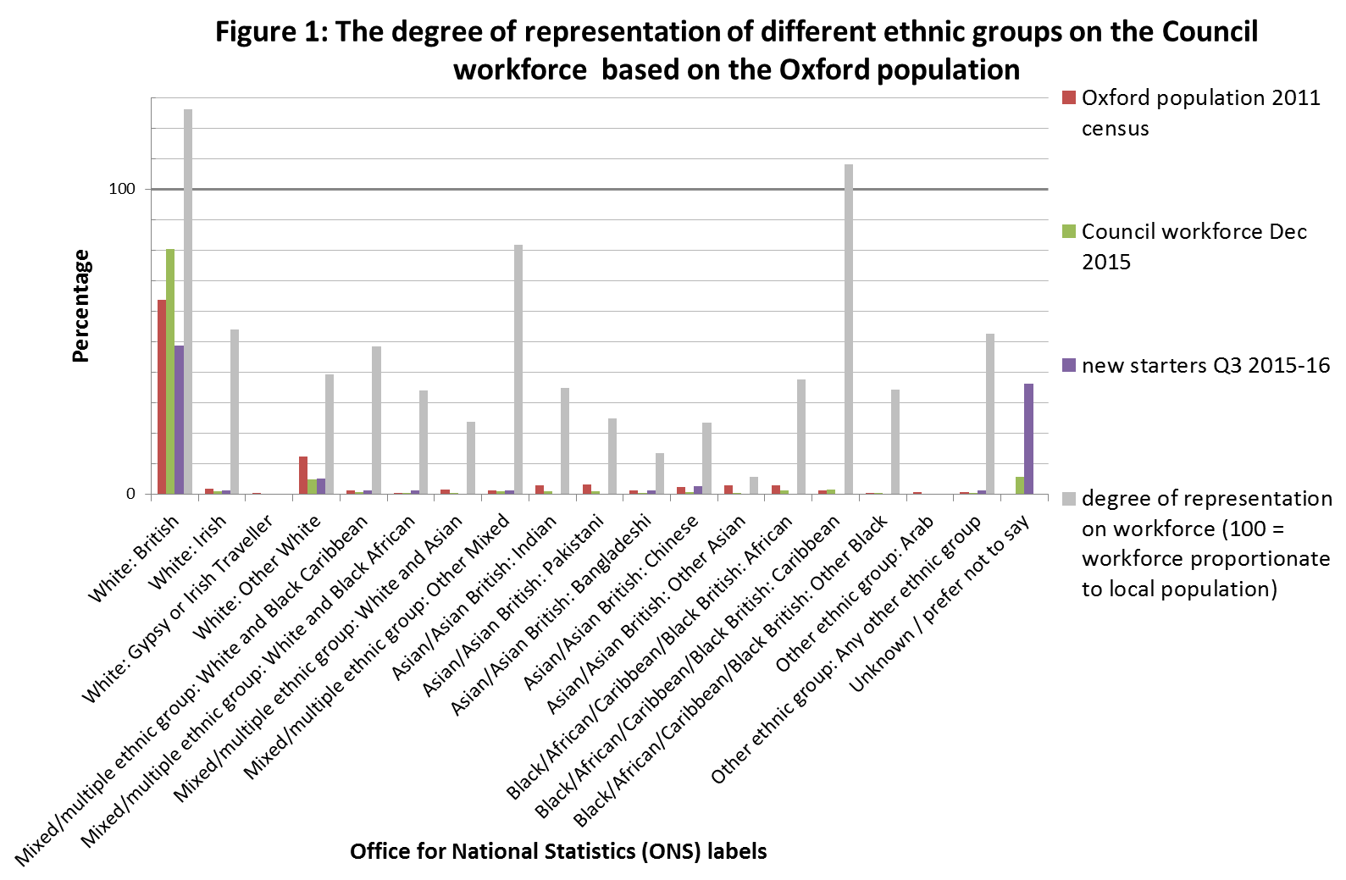

- The Review Group note that it would be unrealistic to expect the profile of the Council workforce to fully reflect the profile of the area it serves (one of the most diverse populations in the region) for a number of reasons.

- Firstly, the diversity of the local population has increased quite considerably in recent years. Population growth in Oxford between 2001 and 2011 was entirely attributable to the increase in residents who were born outside the UK. By 2011 Oxford had 43,000 foreign-born residents making up 28% of the population. The recruitment of many longer-serving employees will have pre-dated these demographic changes and many positions on the Council workforce won’t have become available in that time. Population turnover in the City is relatively high at 25% and significantly higher than the employment turnover rate on the Council workforce, which is about 10%.

- The Oxford population contains groups of people that positively influence the diversity of the City but are not necessarily part of the workforce or seeking employment at the Council. For example, full-time students account for 24% of Oxford’s adult population and approximately one third of these students were born outside the UK.

- Another factor is that the Council does not exclusively employ people who live in the City. The Council is a regional employer with employees who commute to work from as far away as Cheshire, Lincolnshire and Norfolk. The Council’s employment catchment area is therefore less diverse in terms of ethnicity than the City it serves. One distinct reason why a large proportion (53.9%) of Council employees commute is the lack of affordable housing in the City.

- Conscious that over half of Council employees live outside the City boundaries, the Review Group compared workforce ethnicity data with the census information for Oxfordshire, which includes but has a less ethnically diverse population than Oxford. Figure 2 shows that the ethnic profile of the Council workforce is more consistent with the profile of Oxfordshire than it is with Oxford. In this comparison a number of groups remain under-represented on the Council workforce but to a lesser extent than when compared with the population of the City.

- The Review Group looked at the ethnicity of new starters who joined the Council workforce in the 3 months to December 2015. This was a particularly large cohort of new starters due to high recruitment in Community Services. The new starter figures also include electoral staff who are employed on a one-off temporary basis during elections. The ethnic origin of about one third of new starters is unknown but these data gaps may be explained by the inclusion of electoral staff. Either way, Figure 2 shows that the proportion of new starters is higher than the proportion of existing employees for a number of ethnic groups, including some of the most-under-represented groups, such as the Chinese and Bangladeshi groups. This would appear to indicate that the workforce is gradually becoming more diverse.

- Figure 3 provides a breakdown of ethnic groupings by pay grade. The Review Group found that the majority of BME employees are clustered around grades 4-6 and none are higher in the organisation than range 9. Clearly a focus of the Council’s ongoing work must be finding ways to ensure the BME workforce are not clustered in the lowest wage jobs and almost non-existent in senior roles. There are also obvious discrepancies between the different BME groupings in terms of pay grade. The White – all other grouping has some representation up to and including Service Head level but there are very few if any employees from any minority groups in the most senior positions.

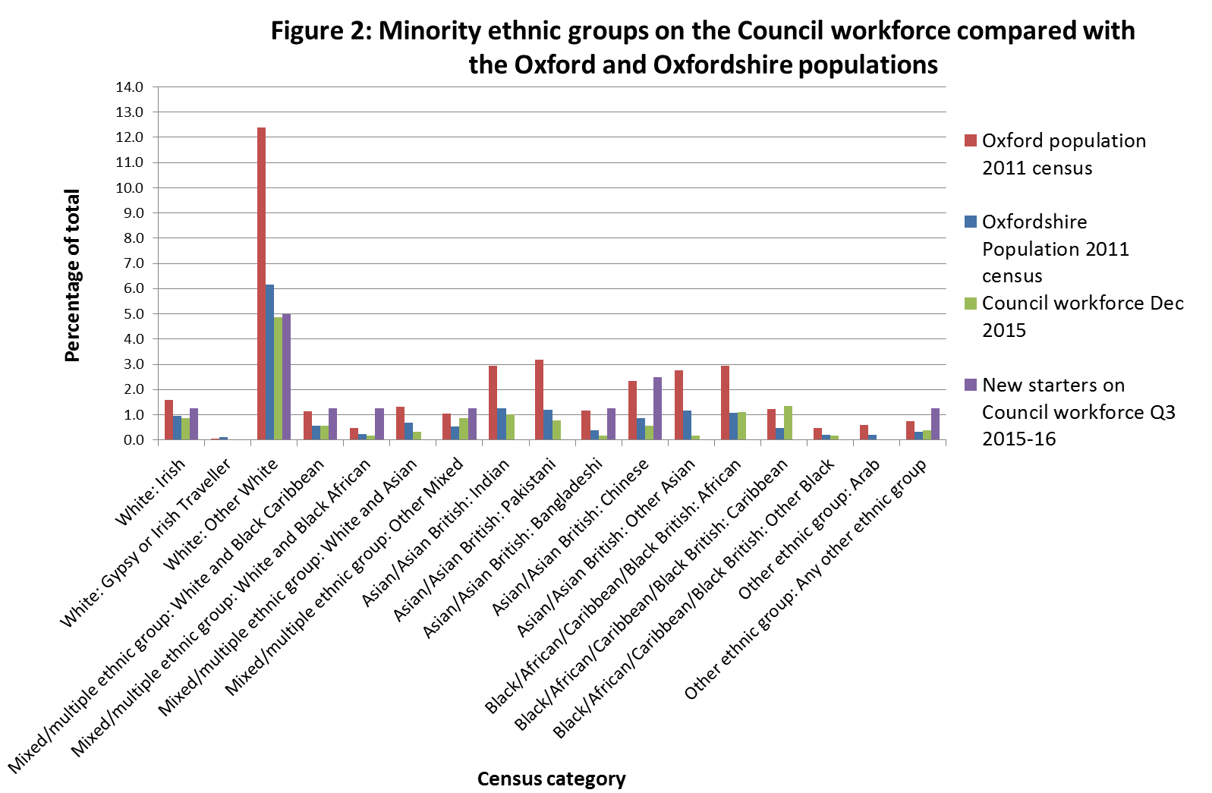

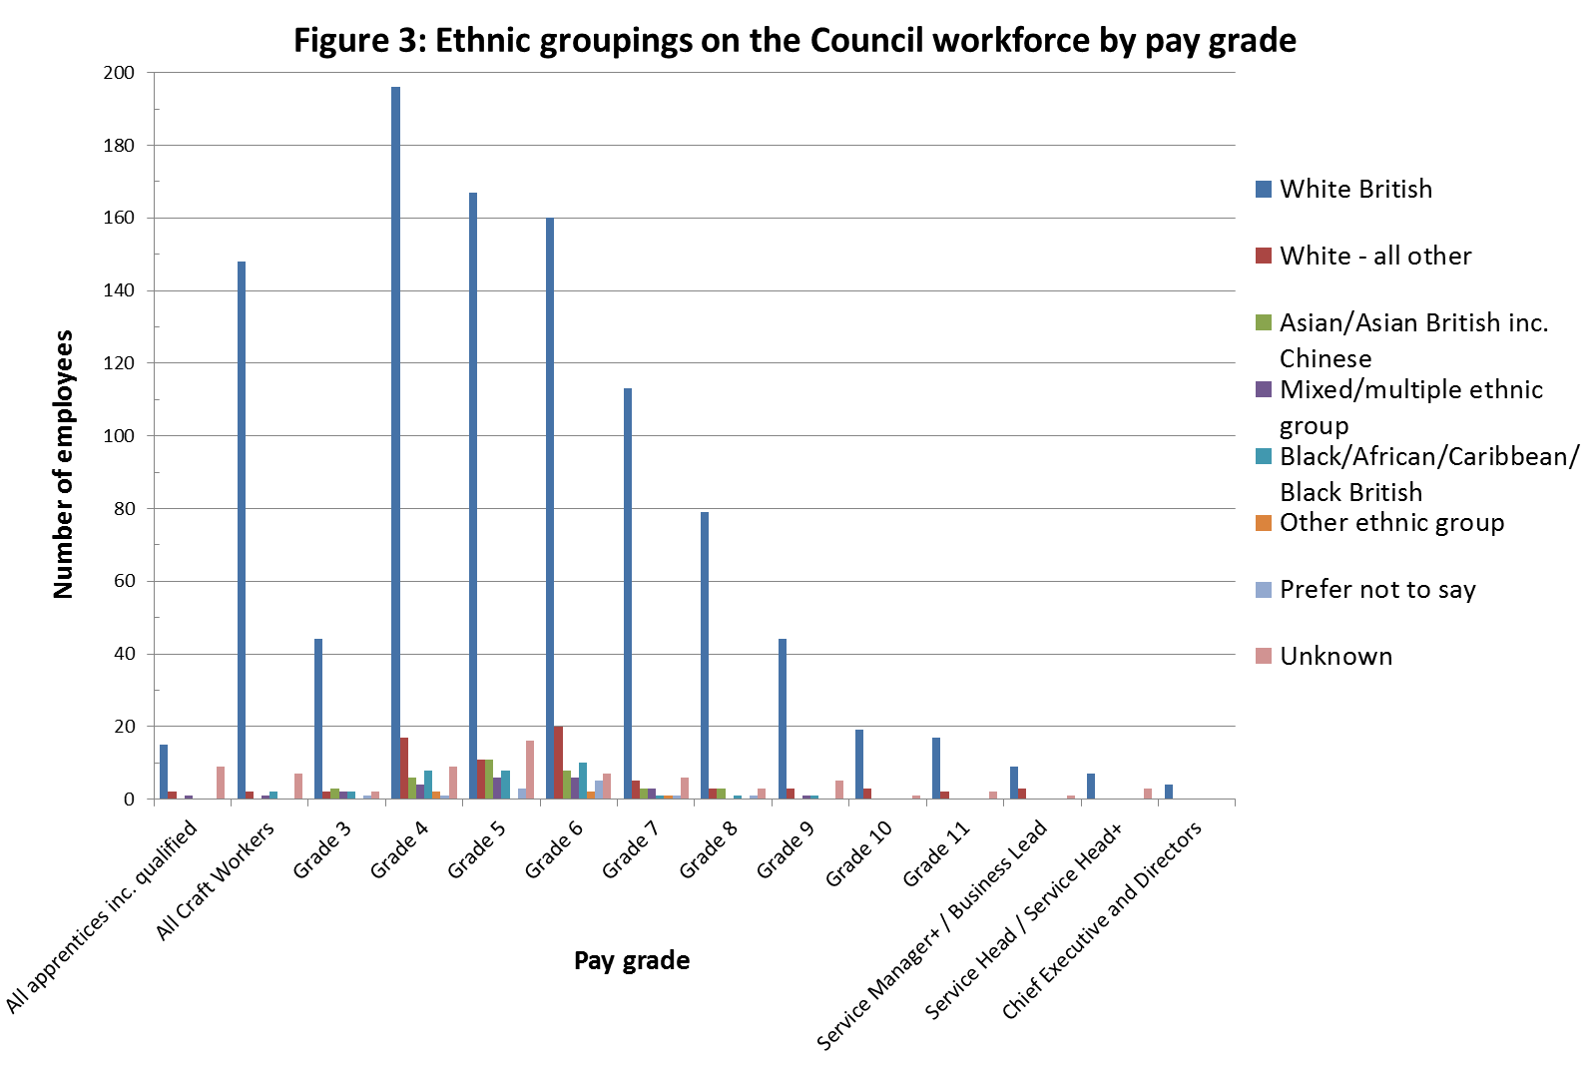

- The Review Group also looked at ethnicity data across the different Council services and Figure 4 provides a breakdown of BME and White Other employment by service area. The Review Group observed that no service area has a workforce that is as ethnically diverse as the population of Oxford. The most ethnically diverse service area is Assistant Chief Executive but this service only has fourteen employees. Of the larger service areas Business Improvement (which includes IT and Customer Services) is the most diverse, with 22.1% of employees identified as being non-White British. This compares with figures of 34.7% for Oxford and 15.4% for Oxfordshire. In contrast, the proportion of non-White British employees in Direct Services, which accounts for approximately half of the Council workforce, is a lot lower at 9%.

- Figure 4 shows that the total Council workforce is less diverse than the populations of both Oxford and Oxfordshire. Excluding Direct Services, the proportions of BME and White Other employees are consistent with the population of Oxfordshire. It should also be noted that the numbers of non-White British employees on the Council workforce are likely to be slightly under-stated because there are some data gaps and a small of employees have selected their ethnic origin as Prefer not to say.

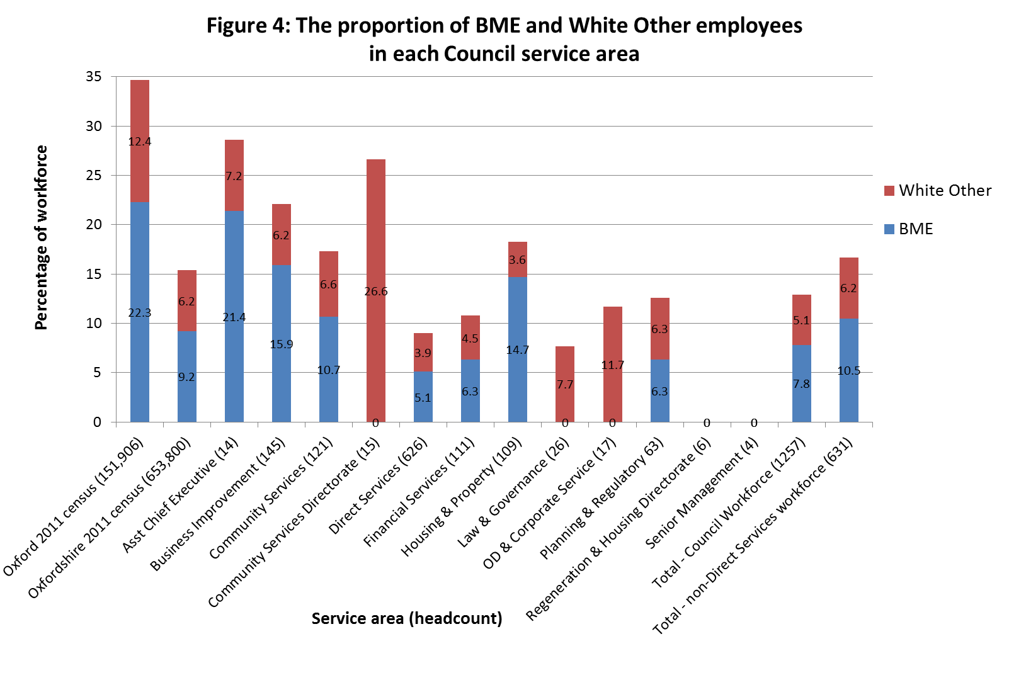

- The Review Group believe that recent increases in the ethnic diversity of the Council workforce are encouraging but that further progress is needed towards achieving a workforce that better reflects the diversity of the population that it serves. The Review Group recognise that progress may be slow and uneven in the short term and that, for the reasons discussed in earlier paragraphs, it would be unrealistic to expect the ethnic composition of the Council workforce to fully reflect the ethnic profile of the City any time soon.

Gender
- The Review Group examined workforce gender data including the gender balance of each service area and at different pay grades, and make a number of observations about the gender profile of the Council workforce.

- Figure 5 provides a breakdown of male and female employees on the Council workforce as a whole, as well as in the Direct Services workforce and the non-Direct Services workforce. In total just over one third (34%) of all Council employees are female. Within this overall figure, Direct Services has a very low proportion of female workers at 12% and this significantly skews the overall figure. Excluding this largely manual workforce, females are actually in the majority, accounting for 57% of the remaining employees. This is considered to be in line with national patterns of employment within local government.

- The Review Group note that the Council has had some successes in increasing female employment in Direct Services. For example, a number of women are now employed as drivers of heavy goods vehicles (HGVs). The proportion of female new starters in Direct Services (22%) is slightly higher than the proportion of females in Direct Services as a whole (12%), which may signify a slight shifting in the gender balance of this service area. However, it is expected that there is little scope to alter the gender balance of the workforce in higher employment areas such as street cleaning in the foreseeable future.

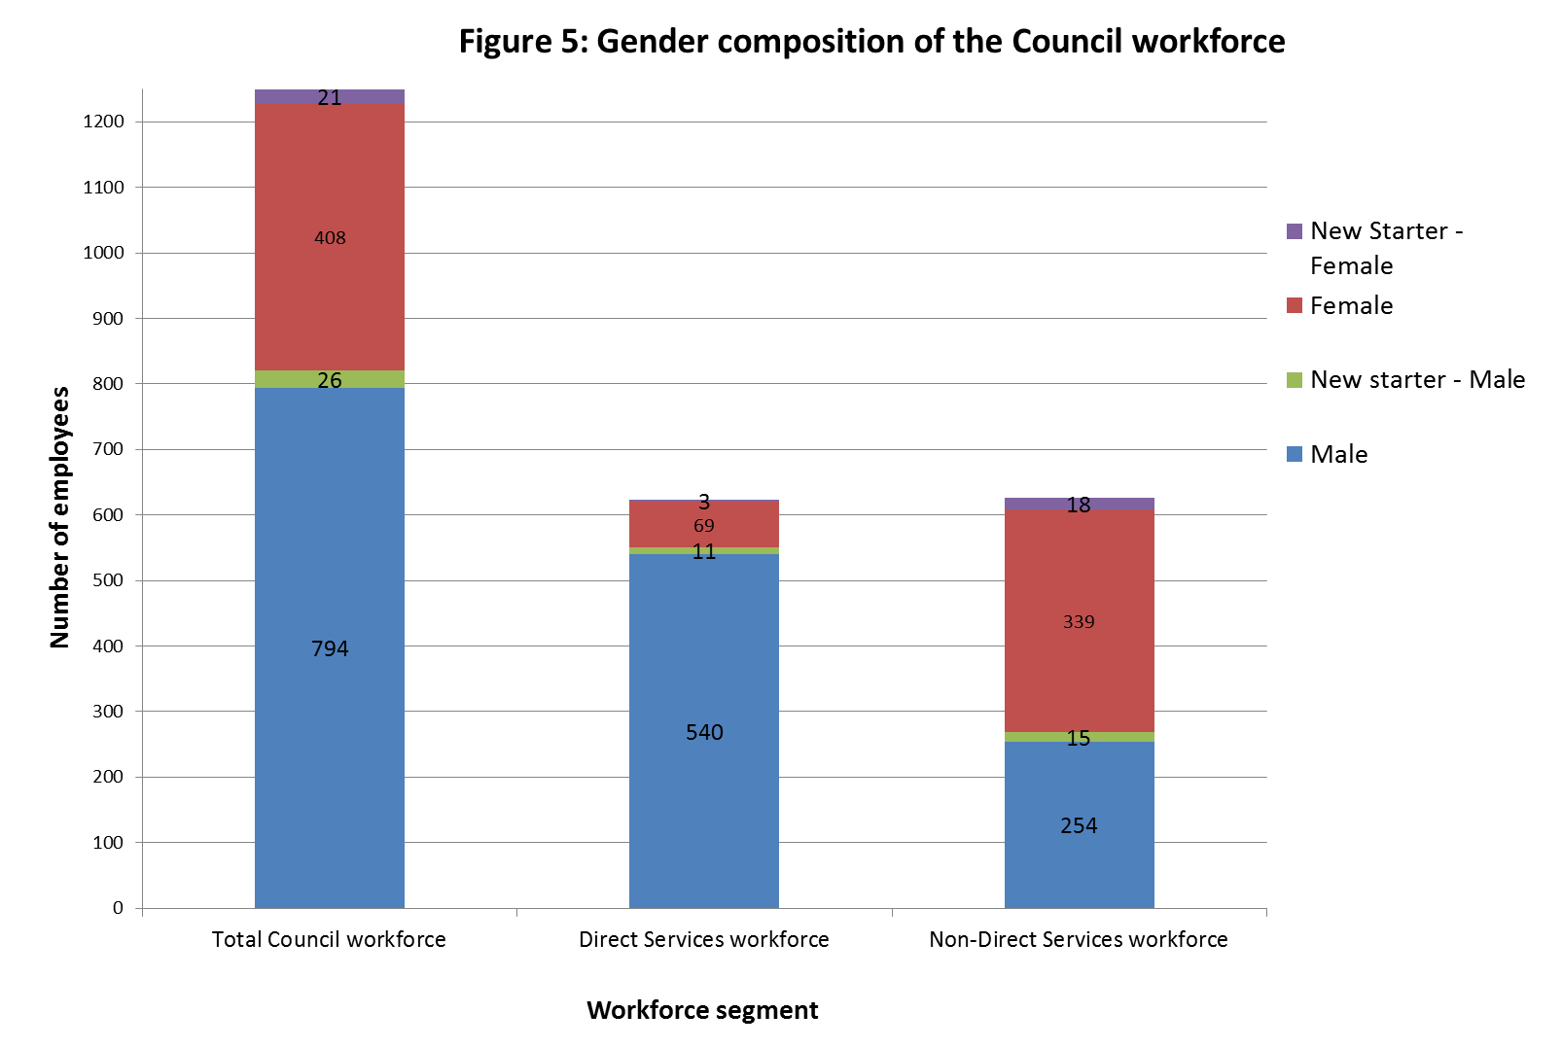
- Figure 6 presents a breakdown of male and female employment in the remaining service areas. It shows that most service areas have a fairly even gender profile or in some cases a majority of female employees. Business Improvement has the highest proportion of female workers at 67%. Male employees are in the majority in two service areas, Senior Management Team and Regeneration and Housing Directorate, both of which have very small numbers of employees.

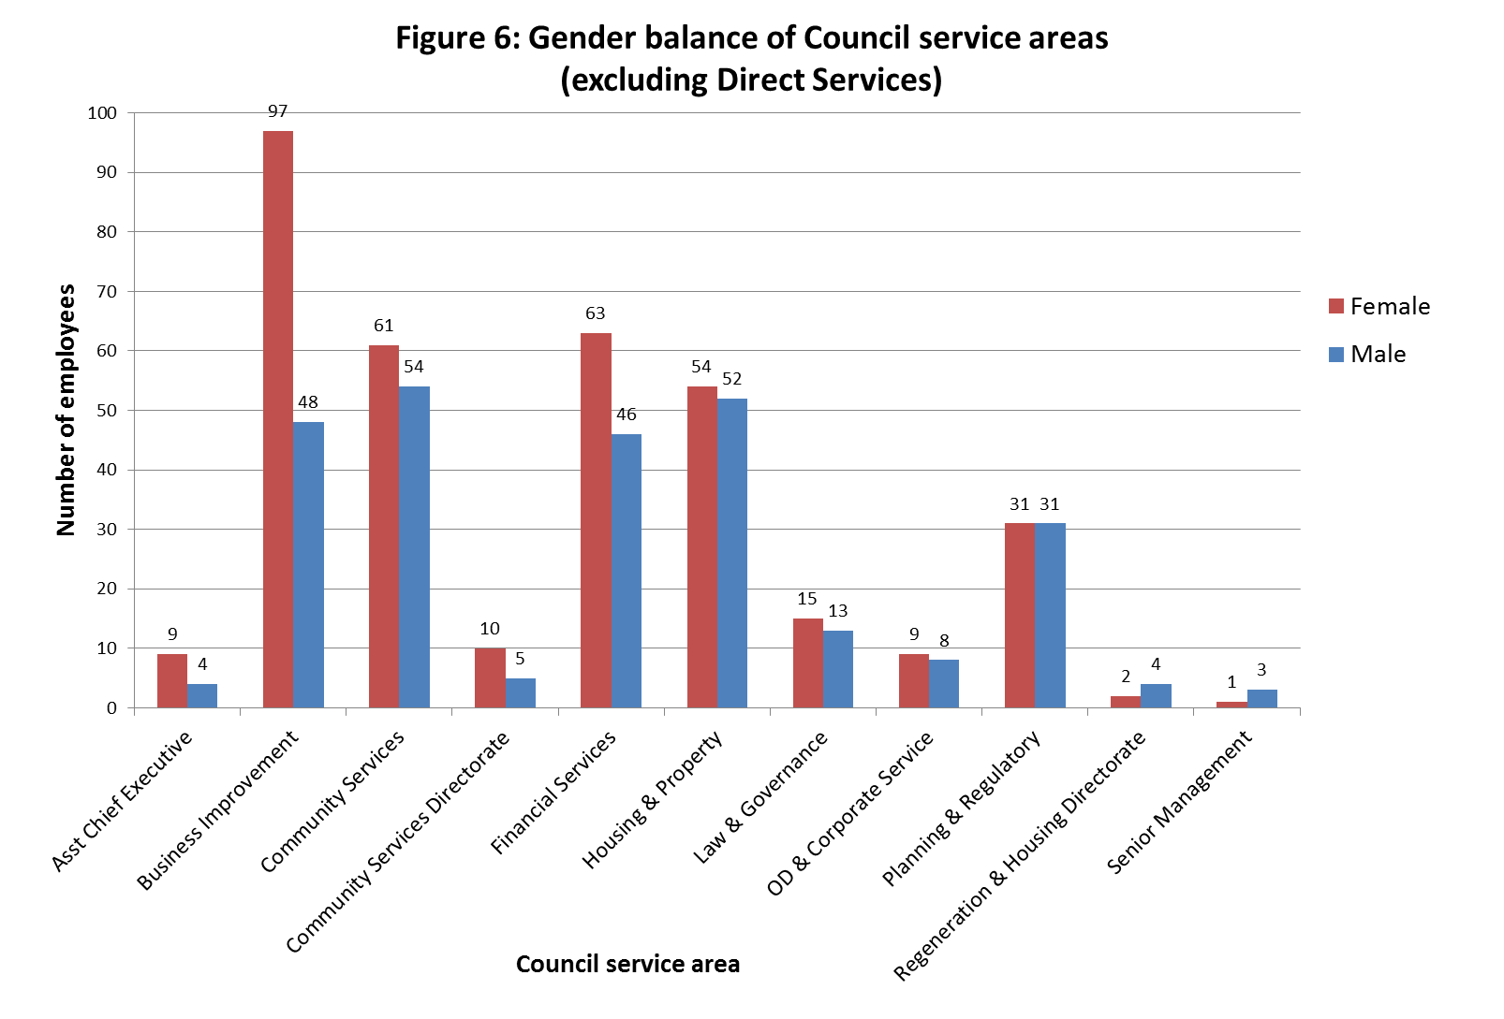

- The gender profile of new starters is broadly consistent with existing patterns of employment in the different service areas, with a notable high proportion of female new starters in Business Improvement and a notably high proportion of male new starters in Direct Services, as shown in Table 1.

Table 1: Male and Female new starters by service area
Service Area | Gender | Employee Count
Asst Chief Executive | Female | 1
Business Improvement | Female | 7
Business Improvement | Male | 2
Community Services | Female | 4
Community Services | Male | 6
Direct Services | Female | 3
Direct Services | Male | 11
Electoral Staff (2012) | Female | 18
Electoral Staff (2012) | Male | 15
Financial Services | Female | 2
Financial Services | Male | 2
Planning & Regulatory | Female | 2

- The numbers of male and female employees at each pay grade is set out in Figure 7. This shows that males outnumber females at every Council pay grade and most notably at the lower Council pay grades (3 and 4) and Craft Worker pay grades, which are Direct Services pay grades linked to productivity. Only one quarter of employees at the lowest two Council pay grades are female, which reflects the large number of Direct Services staff employed at these pay grades. Similarly, one quarter of employees in senior management positions (Service Manager and above) are female. The mid-ranking Council pay grades (5-9) tend to have a more even gender balance.

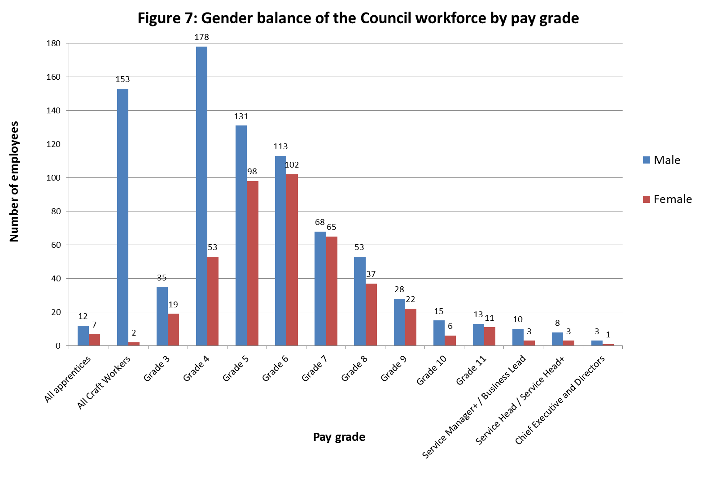

- The Review Group looked at the average hourly pay for males and females within each service area, as well as for the workforce overall. This information is presented in Figure 8, which shows that average hourly pay is higher for men than for women in most service areas. The three exceptions are relatively small teams that have women in senior positions and no more than fifteen employees. High male employment in the lowest paying service area, Direct Services, would appear to even out the average pay rates of men and women at an aggregate level. The net effect of male and female employment patterns is that overall, hourly pay rates for males and females are almost identical. Among full time employees there is a small negative gender pay gap, with average hourly pay for females (£15.69) about 2% higher than it is for males (£15.36).

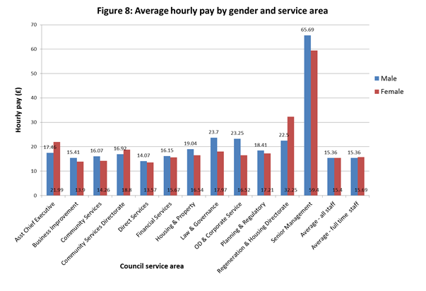

- Table 2 and Table 3 show the numbers of male and female new starters at each pay grade. Most new starters were recruited at pay grades 3-8. A small number of new starters joined at higher pay grades, including a female at Service Manager level. This was the highest post recruited to during the three month period of October to December 2015.

Table 2: Female new starters by pay grade
Gender | Grade | Employee Count
Female | Grade 03 | 6
Female | Grade 04 | 4
Female | Grade 05 | 3
Female | Grade 06 | 4
Female | Grade 07 | 2
Female | Grade 09 | 1
Female | Service Head | 1

Table 3: Male new starters by pay grade
Gender | Grade | Employee Count
Male | Craft Worker Band B | 2
Male | Craft Worker Band D | 1
Male | Grade 03 | 3
Male | Grade 04 | 5
Male | Grade 05 | 5
Male | Grade 06 | 5
Male | Grade 08 | 3
Male | Grade 10 | 1
Male | Not Defined | 1

- The Review Group requested statistics to see the gender of breakdown of minority ethnic groups on the Council workforce and this data is presented in Figure 9. It shows that there are more males than females in most minority groups, most notably in the Black groups. There are more females than men in two ethnic groups; the Indian and Chinese groups. However, there are also more females in the Prefer not to say category, so overall the numbers of male and female employees are likely to be fairly even in most groups.

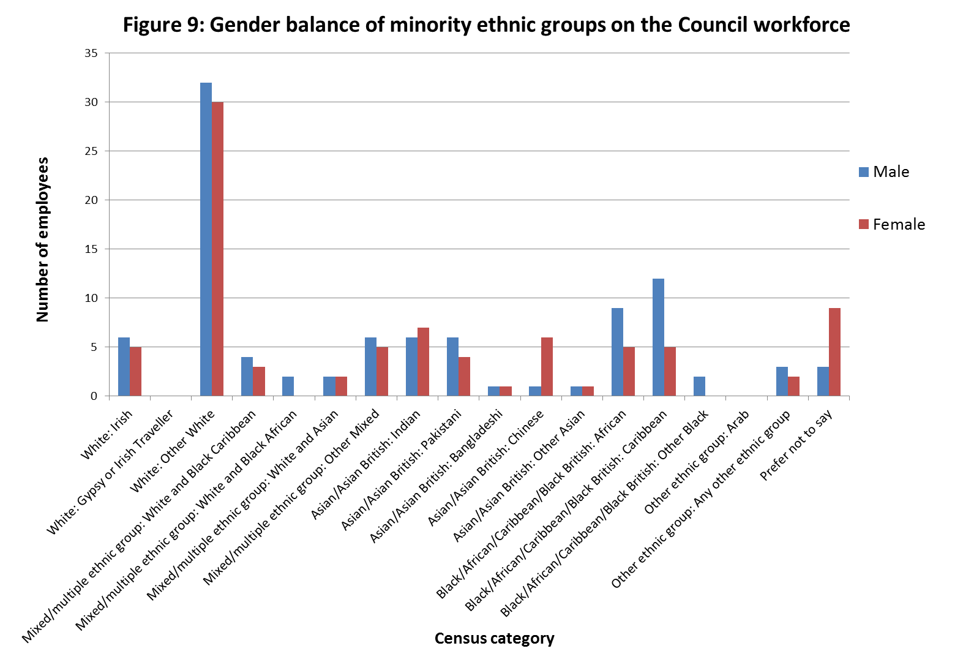

Sexual orientation
- The Review Group found that the numbers of Council employees who have declared their sexual orientation to be something other than Heterosexual/straight are very low, at around 1% of the total workforce, as shown in Table 4. This number is likely to be understated because there are significant data gaps, with 40% of the workforce either Unknown or Prefer not to say.
- The relatively high number of Prefer not to say responses may reflect employees taking the view that this is private information their employer does not need that does not affect their job. However, assuming that there is not a problem in disclosing sexual orientation may mean the Council misses a problem, namely that LGBT employees do not feel comfortable being out in their workplace. Assuming that there is not a problem in disclosing sexual orientation may in effect exacerbate any problem that did exist.

- Of the 60% of employees who have provided their sexual orientation, 98% responded that they are Heterosexual/straight. Given the small numbers of non-heterosexual returns, the Review Group did not see much value in analysing this data by service area or pay grade and would encourage efforts to obtain a more complete dataset.

Table 4: Sexual orientation of the Council workforce
Sexual Orientation | Employee Count
Bisexual | 1
Gay man | 6
Gay woman/lesbian | 5
Heterosexual/straight | 736
Prefer not to say | 70
Unknown | 439

- Amongst new starters, the number of unknowns is the same as the number of new electoral staff. This could be a coincidence or it could be that new electoral staff had not been asked to declare their sexual orientation while all other new starters declared their sexual orientation to be Heterosexual/straight. Either way, the new starter sexual orientation returns shown in Table 5 are broadly consistent with (and do little to alter) the profile of the Council workforce as a whole.

Table 5: Sexual orientation of new starters
Sexual Orientation | Employee Count
Heterosexual/straight | 47
Unknown | 33

- Without more complete data it is very difficult to know the extent to which LGBT groups are actually under-represented on the Council workforce, although the available data would suggest that they are.

Disability
- Table 6 shows that as of the end of January 2016, 103 Council employees had declared a disability, which equates to 8.2% of the workforce, against a target of 10%. The Council cannot require staff to declare a disability and the actually figure is thought to be slightly higher as the data gaps include staff known to have a registered disability who are being supported at work.

- The proportion of employees declaring a disability is lower than the 12% of people who said they suffered from a limiting long-term illness or disability in the 2011 Oxford census. Disability is strongly related to age so this population figure will include disabled people who are retired, as well as 3,100 people aged 16-74 who are economically inactive due to being permanently sick or disabled.

- Relatively few employees have declined to specify whether they have a disability but it may be that amongst the Not known group includes people who do not wish to provide this information to their employer or do not see the value in doing so.

Table 6: Disability data for the Council workforce
Disability Type: People | Employee Count
Declined to specify | 9
Disabled | 103
Not disabled | 1072
Not known | 73

- Amongst the new starter cohort the proportion of staff declaring a disability is lower at only 5%. The new starter figures shown in Table 7 include temporary electoral staff but even excluding these staff the proportion of new starters declaring a disability is not high enough to positively impact performance against target. Indeed, the proportion of employees declaring a disability fell from 8.45% in December 2015 to 8.2% in January 2016. Performance against this measure will be affected by small numbers of disabled staff leaving the organisation, or by a lower rate of new starters declaring a disability. It should therefore be expected that this figure may go up or down slightly in the short term but the Review Group would expect that over a longer period the trend should be for a steady increase in the number of employees declaring a disability.

Table 7: Disability data for new starters
Consider Disabled? | Employee Count
No | 75
Not Known | 1
Yes | 4

Age
- Figure 10 shows the age profile of the Council workforce, which ranges from 16 to 85. The age profile peaks in the early 50s age group, with the most common ages of Council employees being 51 and 52. The 10 most common ages all range from 43 to 58, which includes the tail end of the baby boomer generation.

- This data includes some 373 electoral staff, which may explain some of the 33 staff aged 70+. However, the default retirement age has been phased out, so most people can now remain in work for as long as they want to.

- There are reasonable numbers of employees in the mid-twenties to mid-thirties age groups but employment numbers then dip significantly, with relatively few employees aged 36-41. This may reflect the challenges around the unaffordability of housing in the city and the fact that many young professionals tend to house-share in their twenties and early thirties but are ultimately unable to buy a home and settle in the area long-term.

- The Review Group heard that the aging workforce presents a number of challenges to the organisation. These include the need to recruit from younger age groups and potentially the need to support larger numbers of employees with disabilities as working lives, including manual working lives, are extended.

Figure 10: Age profile of the Council workforce (including electoral staff)
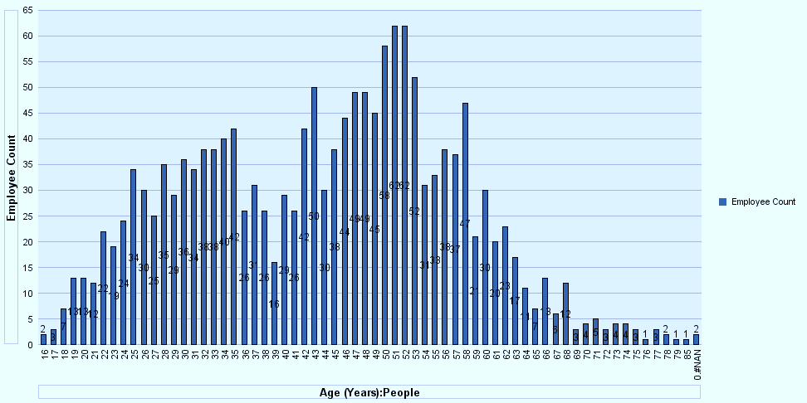

Barriers to recruitment and career progression

- The Review Group identified a number of barriers that are potentially faced by under-represented groups in recruitment and career progression at the Council. These include relatively low rates of staff turnover in parts of the organisation, recruitment processes, access to qualifications, skills and experience, and possibly the culture of the organisation and how the Council is perceived by different groups. Some under-represented groups will face other more-specific barriers. For example, women are more likely than men to take career breaks in order to raise children and disabled people are more likely to face barriers to do with accessibility.

- The Council has a relatively high workforce turnover at 10% per year, which equates to some 20-30 new recruits joining the workforce in a typical quarter. This is not necessarily high enough to keep pace with demographic changes in a city with a 25% annual population turnover, particularly given that half of new recruits come from areas outside the city that are generally less diverse. Despite this, the Review Group heard that the proportion of job applications received from BME applicants is at its highest ever level at around 22%. The conversion rate drops off during the recruitment process and the proportion of new starters from BME groups is significantly lower only around 14%. The reasons for this are unknown but there are likely to be several factors. The Review Group heard that some BME applicants are not credible applicants, for example because they do not have a visa to work in the UK. Skill sets including language skills and interview performance may also be factors.

- Some positions at all levels in the organisation will be held by long-serving employees and will become available very infrequently, such as when the post-holder retires or dies. Many of these employees will have been recruited prior to recent demographic changes. This factor is known as ‘dead man’s shoes’ and it is a barrier to the recruitment and career progression of people who are looking to be appointed to these roles. High turnover rates among younger employees would indicate that they are willing to leave the organisation to pursue their careers elsewhere if opportunities do not become available, particularly given the very high cost of living in the city.

- Opportunities for under-represented groups to reach the highest levels of the organisation are particularly limited due to the very small number of these posts and the fact that they become available infrequently. When higher-paid roles do become vacant, successful applicants are likely to be recruited from within the local government sector, where BME groups are generally under-represented. The profile of the Council’s senior management team would therefore not be expected to change significantly in the short to medium term. Ethnic groups that are newer to the population will take time to gain the equivalent skills and experience necessary to be successfully recruited to these types of roles. Indeed, the Review Group heard that over one third of applicants for the lowest paid range 3 positions are qualified to degree level or higher, so a lack of qualifications is likely to be a barrier at various levels of the organisation.

- Some roles that the Council recruits such as Lawyers and Chartered Surveyors require professional qualifications that are not always inclusive and accessible to under-represented groups. The Council has little or no control over access to qualifications yet the pool of professionals it recruits from will in many cases be less diverse than the population it serves.

- Similarly, the Council has little influence on young people’s career choices, which are much more likely to be influenced by information provided by parents and social media. Many lower-paid roles on the Council workforce such as manual roles in Direct Services may be seen as traditionally jobs for white working class men. These roles, which make up a significant proportion of the Council workforce, may not be desirable to under-represented groups such as women and ethnic minorities. Questions around what routes into employment people in different communities want and whether the Council is seen as an attractive employer need to be better understood. While the Council has had some success at recruiting female HGV drivers, there is little scope to significantly alter the gender balance of the Direct Services workforce in the medium term.

Reducing barriers
- The Council has already sought to ensure that the profile of its workforce better represents the local community. The Council pays an Oxford Living Wage, offers flexible working and has employment policies and practices in place that are aimed at achieving equality of opportunity for all. The Council is legally able to use positive action in certain circumstances to help people with protected characteristics to overcome their disadvantage and has done so in a variety of ways. It also has specific targets in place for the employment of BME and people with disabilities. The Review Group support this positive action.

- The Council has taken a number of steps to make its recruitment processes more flexible and accessible to different under-represented groups. Improvements include reviews of job descriptions and the placement of job adverts, the provision of online advice and guidance to applicants and basing recruitment decisions on more than just an interview. Feedback is now offered to all applicants who are unsuccessful at the interview stage. The Council has also trialled anonymised shortlisting for a period of time but this was found to make no difference to recruitment outcomes.

- The Council’s workplace premises, which are currently in the process of being rationalised, need to be safely accessible to people with disabilities and compliant with disability equality laws. The Review Group understand that advice has been sought on all design standards for workplace refurbishments and new build projects and that fire risk and evacuation plans are in place. The Review Group suggest that the Council undertakes or organises accessibility audits on an ongoing basis to continue to ensure compliance and identify reasonable adjustments. Accessibility is about more than getting into buildings, it's also about employees easily accessing reasonable adjustments in the workplace and online resources. These audits should also cover issues of public accessibility. Consideration should be given to how frequently accessibility audits should take place at each workplace premises and the Council could look at setting maximum intervals between accessibility audits.

Recommendation 1 – That the Council undertakes accessibility audits of its employment premises, public-facing information (for instance, on the website) and externally available application forms, at appropriate intervals. Consideration should be given to how frequently these audits should take place at each workplace premises and to the setting of maximum intervals between audits.

- The Review Group noted in discussion that millennial workers (those born after 1979) look for different things from a job and from an employer than older demographics and questioned whether more traditional adverts for local government vacancies would appeal to these groups. The Review Group heard that there is a need to understand what younger people want but that officers need time to be proactive rather than reactive in these sorts of areas. The Review Group support the review of recruitment which is already underway and suggest that the Council should continue to explore ways of making its recruitment processes more appealing and accessible to young people and other under-represented groups. This should include looking at the way job adverts are presented and branded as well as where they are placed, with a view to making them more inclusive.

Recommendation 2 – That the Council reviews recruitment branding to better target vacancies at under-represented groups and young people, including utilising settings or channels that are less traditional to local government but more inclusive.

- The Review Group heard that BME employees had been encouraged to contribute to focus group discussions about what the Council was seen as standing for and what prevented these groups from applying for vacancies at the Council. There have also been a number of outreach activities to encourage under-represented groups to apply for jobs at the Council, including at job fairs and other events in community settings. The Council is also able to reach out to young people in schools through the Business in the Community partnership. The Review Group heard that attendance at community events had been poor amongst target groups and while the Council’s Communities Team is working to build relationships with different communities in the City, progress is slow. The Review Group encourage and support continued efforts to reach out and build relationships with under-represented communities in a variety of ways.

Recommendation 3 – That the Council continues to promote itself as an inclusive employer through outreach activities including continuing to hold open recruitment sessions in community settings, reaching out in schools through the Business in the Community partnership, and attending job fairs and community meetings.

- The Review Group considered whether the Council could extend its reach further into communities by placing job advertisements in community settings. This would need to be done at low cost and is likely to be most effective when the Council recruiting in bulk to multiple vacancies. The Review Group support moves to utilise community centres and potentially community newspapers and social media platforms.

Recommendation 4 – That the Council investigates opportunities to advertise multiple vacancies in community settings at low cost, which could include making use of community newspaper social media platforms, as well as community newspapers and, as long as those running them are willing, community centres.

- Similarly, the Review Group also suggest that the Council could make use of its own assets, such as Streetscene vehicles, in promoting itself as an inclusive employer around the city.

Recommendation 5 – That the Council makes use of its assets to promote itself as an inclusive employer, including Streetscene vehicles.

- The Review Group questioned what arrangements the Council has in place to manage and promote talent within the organisation and whether any support is specifically targeted at under–represented groups. The Review Group heard that talent management within the organisation is not specific to succession planning or to helping to further the careers of employees from under-represented groups. The Review Group suggest that officers explore whether there would be an appetite amongst employees from under-represented groups for a more targeted talent management system and seek ideas for what types of support such a programme would include.

Recommendation 6 – That the Council reviews its Talent Management Framework and researches whether the inclusion of a more targeted talent management programme would appeal to under-represented groups, as well as what such a programme would include.

- The Review Group noted that language can be a barrier to some under-represented groups in accessing Council services and heard that customer-facing employees who could speak a second language did utilise these skills in assisting customers. The Review Group suggest that when the Council is recruiting to certain customer-facing roles it could include the ability to speak a second language as a desirable criterion in the role profile. This should be limited to languages spoken by communities based in the city and to roles that are likely to come into contact with members of these communities. Recognising the ability to speak a second language as a useful skill may help to encourage applicants from under-represented communities to apply successfully for roles on the Council workforce.

Recommendation 7 – That the Council emphasises the value it attaches to the ability to speak a second language by including this skill in the desirable criteria for selected customer-facing job vacancies, such as Tenancy Management Officers and Customer Service Officers.

- The Review Group questioned whether the Council could make more use of language skills of employees across the organisation in assisting customers. It is suggested that the Council should identify priority skills that may not currently be utilised (such as the ability to speak a second language) and undertakes a skills audit with the aim of finding and utilising these skills within its workforce.

Recommendation 8 – That the Council undertakes a workforce skills audit with the purpose of identifying priority competencies and hidden talents that aren’t currently being utilised but would benefit to the organisation, including the ability to speak a second language.

- The Review Group also suggest that there may be an opportunity to actively utilise employees with the ability to speak a second language by asking to have them ‘on call’ to speak with customers. If this would address a business need then consideration should be given to rewarding these staff with a small pay supplement, similar to than give to fire wardens for example.

Recommendation 9 – That the Council considers the feasibility of having staff who are known to speak a second language ‘on call’ to communicate with customers who speak little or no English, and whether these staff could be rewarded with a small pay supplement.

Preventing and addressing discrimination

- The Review Group considered how the Council deals with discrimination and found that instances of conscious or subconscious discrimination are not showing through in the Council’s reporting. There are perhaps 3-4 grievance cases each year and these tend to relate to issues of care of property. Occasional cases of discrimination or bullying have been dealt with effectively and a small number of employees have been dismissed in recent years as a result. The Review Group considered whether there may be a macho culture in parts of the organisation that was exclusive of under-represented groups, and whether this type of culture may be present in a more subconscious sense in office based environments.

- The Review Group questioned what types of information the Council gathers in employee surveys and exit interviews and what the results indicate in terms of employees’ experiences and perceptions of the culture of the organisation. Previous staff surveys have included questions around discrimination but not since 2013, so no recent and useful staff survey data is available. Exit interviews are offered to all leavers but many leavers appear to lack the motivation to take these up and are thought to move on for a range of internal and external factors. The Review Group heard that exit interviews tend to produce low quality data and this may be because many leavers wish to keep their options open for the future, or possibly to draw a line under any negative experiences they may have had.

- As would be expected from a public sector organisation, the Council has robust anti-discrimination policies and reporting procedures in place and also benefits from strong trade unions and the work of HR Business Partners. The Review Group suggest that the Council’s policies around anti-discrimination should have a high profile within the organisation, including on the Council Intranet, as part of efforts to maintain an inclusive culture.

Recommendation 10 – That all Council employees are reminded of the Council’s Fair Employment Statement and employment policies at least annually. These documents should also be prominent and easily accessible on the Council’s Intranet.

- The Review Group note the importance of regularly getting the right messages across to staff in order to help them to recognise and prevent instances of discrimination. The Review Group expect that senior employees lead by example in challenging discriminatory language and behaviours and suggest that all staff should be made aware and reminded of their responsibilities to do so as a matter of course.

Recommendation 11 – That all Council employees are at least annually made aware of their responsibility to challenge discriminatory language and behaviour in the workplace, wherever that may be, as matter of course.

- The Review Group questioned whether employees are provided with training to help them to tackle discrimination and suggest that training on recognising unconscious bias should be prioritised and focused on the Council’s HR Business Partners and the managers across the organisation most regularly involved in recruiting cohorts of new starters. The Review Group heard that this training could be delivered in house or sourced at a relatively modest cost. The Review Group also suggest that once this training has been delivered it should be followed up with refresher courses, perhaps annually.

Recommendation 12 – That unconscious bias training is provided to the Council’s most frequent recruiting managers and HR Business Partners. Ideally this would be followed up with annual refresher courses in order to maintain awareness and compliance with good practice.

Being inclusive of LGBT employees
- Specific consideration was given to whether the Council is inclusive of LGBT people generally and transgender people in particular. The Review Group has recommended that further consideration should be given to why the LGBT workforce is small and less willing to disclose.

- The Council pays a sum each year to show that it is an LGBT inclusive employer and acquire advice on being more inclusive by being a Stonewall Diversity Champion. The Review Group questioned the value for money of retaining this status given that the only benefit to the Council, as reported by officers, is use of the Stonewall’s Diversity Champion logo. The Council must be mindful of the financial investments it makes and if there is no tangible evidence to suggest that being a Stonewall Diversity Champion has made or is making a positive difference in attracting and retaining LGBT staff, consideration should be given to obtaining better value from Stonewall and, failing that, dedicating the funding to other means of tackling discrimination, such as training recruiting managers.

- Bearing in mind that the LGBT workforce is small and less willing to disclose, consideration should be given to the tension between the message that might be sent out by declining to continue as a Stonewall Diversity Champion and the quite strong practical benefits that could accrue to recruitment and better rates of disclosure from better spending that sum of money.
Recommendation 13 – That the Council seeks to obtain better value from its status as a Stonewall Diversity Champion and, failing that, considers whether the small membership fee would be better invested in other means of tackling discrimination.

- As discussed in paragraphs 34-36, there are significant gaps in the sexual orientation data held by the Council, as well as to a lesser extent the disability and ethnicity data. Evidence shows that sexual orientation is considered to be more private than other equalities data that is routinely monitored. The Review Group suggest that the Council should continue to encourage employees to provide this data, explaining why this data is held by the organisation and how it can help ensure fairness and equality at work.

Recommendation 14 – That the Council continues to ask employees to review and complete their personal details, including sensitive information such as their sexual orientation, on at least an annual basis, as well as continuing to target identified data gaps. Explanation should be provided as to why sensitive personal information is held by the organisation and the wider benefits of doing so.

- Consideration was given to the inclusion of the Prefer not to say option for sexual orientation on the Council’s monitoring form. The inclusion of this option may send a signal that this data is something that should be considered private. It also produces data that can be difficult to use and analyse and some employers such as IBM and Brighton and Hove Council do not provide this option. At the same time the Prefer not to say option provides individuals with the choice not to disclose their personal data and recognises that this information is shared on a voluntary basis. The Unison guidance on LGBT workforce monitoring advises employers that ‘questions on sexual orientation and gender identity should always include a ‘prefer not to select’ option’. The Equality and Human Rights Council report Improving Sexual Orientation Monitoring includes case study examples of good practice. These examples include how an employer significantly increased sexual orientation disclosure rates and how another employer has effectively communicated why personal data is monitored. The Review Group suggest that the Council should continue to keep national good practice and its own monitoring arrangements under review.

Recommendation 15 – That the Council maintains a watching brief on good practice in workforce equalities monitoring and continues to keep its own monitoring arrangements under review, including how questions are asked and the language used as well as the continued inclusion of a ‘prefer not to say’ option.

- The personal information the Council holds on employees is not currently inclusive of transgender people because being transgender is not a form of sexual orientation, it is a matter of gender identity or gender history. The Review Group suggest that consideration should be given to monitoring the gender identity of employees in addition to sexual orientation. This would need to be done in accordance with good practice, which would include consulting with staff, and with the purpose of identifying discrimination and building equality. If done with care and confidentiality, the monitoring of gender identity would over time help to demonstrate that the Council is committed to building an LGBT friendly workplace. The Unison factsheet on LGBT workforce monitoring provides useful guidance including dos and don’ts that the Council should follow.

Recommendation 16 – That consideration is given to whether the sensitive personal data of applicants and employees requested and held by the Council should be more inclusive of transgender people. For example, the Council should consider consulting with appropriate individuals and Trade Unions on adding an appropriately worded gender identity field to its monitoring forms, with the clear purpose of building equality and identifying discrimination.

- The Review Group also considered the use by the Council of gendered titles such as Mr and Mrs, which are not inclusive of transgender people, to address employees and customers. The Review Group note that the use of the gender-neutral title Mx is inclusive of transgender people and is gradually becoming more widely used and accepted in the UK, including on government forms. Consideration should be given to including Mx alongside the more established titles on Council forms and databases.

Recommendation 17 – That the Council adopts gender-neutral terms on forms as part of its ongoing work to be as inclusive as possible, for instance, giving consideration to adding the title Mx in addition to the more established gendered titles such as Mr, Mrs, Miss and Ms.

- Consideration was given to the extent to which the continued inclusion and use of titles on Council forms and correspondence will be necessary in future. The Review Group suggest that, with Trade Union support, these could ultimately be phased out on some or all Council forms over the coming years.

Recommendation 18 - That consideration is given to whether there is merit in phasing out the use of titles on Council forms and databases over the medium term if this would be supported by the Trade Unions.

Conclusion

- The Review Group conclude that the Council has good policies and measures in place aimed at helping to overcome barriers faced by under-represented groups and to tackle discrimination. As a result, steady progress has been made over recent years in ensuring that the Council workforce is gradually becoming more representative of the diverse communities it serves. The Review Group welcome the progress made and encourage further improvements, particularly in relation to ensuring that the Council’s employment practices are more inclusive of transgender people.

Name and contact details of author:-
Andrew Brown on behalf of the Scrutiny Committee
Scrutiny Officer
Law and Governance
Tel: 01865 252230 e-mail: abrown2@oxford.gov.uk

List of background papers: None
Version number: 1.0

Annual Workplace Equalities Report 2014-15, Oxford City Council, 2015
Students in Oxford, Oxford City Council
Annual Workplace Equalities Report 2014-15, Oxford City Council, 2015
Disability, Oxford City Council, 2016
Retirement age, Gov.uk, 5 February 2016
Discrimination at work - positive action, Citizens Advice, 2016
Improving sexual orientation monitoring, Equality and Human Rights Commission, 2010, p. 5
Improving sexual orientation monitoring, Equality and Human Rights Commission, 2010, p. 20
LGBT workforce monitoring, Unison, p. 4
Gender neutral honorific Mx 'to be included' in the Oxford English Dictionary alongside Mr, Ms and Mrs and Miss, The Independent, 3 May 2015

